ID:__________

**Scoring sheet: Errand Planning**

|  |  |  |  |  |  |
| --- | --- | --- | --- | --- | --- |
| **Step** | **Aisle (letter)** | **Item # (or NA, if no items and just back to map)** | **Back to map?** | *For later coding 🡪* | **Correct or incorrect item?** |
| 1 |  |  | Y N |  | 0 1 |
| 2 |  |  | Y N |  | 0 1 |
| 3 |  |  | Y N |  | 0 1 |
| 4 |  |  | Y N |  | 0 1 |
| 5 |  |  | Y N |  | 0 1 |
| 6 |  |  | Y N |  | 0 1 |
| 7 |  |  | Y N |  | 0 1 |
| 8 |  |  | Y N |  | 0 1 |
| 9 |  |  | Y N |  | 0 1 |
| 10 |  |  | Y N |  | 0 1 |
| 11 |  |  | Y N |  | 0 1 |
| 12 |  |  | Y N |  | 0 1 |
| 13 |  |  | Y N |  | 0 1 |
| 14 |  |  | Y N |  | 0 1 |
| 15 |  |  | Y N |  | 0 1 |
| 16 |  |  | Y N |  | 0 1 |
| 17 |  |  | Y N |  | 0 1 |
| 18 |  |  | Y N |  | 0 1 |
| 19 |  |  | Y N |  | 0 1 |
| 20 |  |  | Y N |  | 0 1 |
| 21 |  |  | Y N |  | 0 1 |
| 22 |  |  | Y N |  | 0 1 |
| 23 |  |  | Y N |  | 0 1 |
| 24 |  |  | Y N |  | 0 1 |

|  |  |  |  |  |
| --- | --- | --- | --- | --- |
| **Correct** | **Omission errors (forgotten)** | **Commission errors (falsely selected)** | **Total time\*\*** | **Path Length** |
|  |  |  |  |  |

** Time starts with the bugle flourish, and ends with the “thank you”.

**My list**

* Kraft 2% Sharp Cheddar Cheese (*Cheese*)
* Organic Girl Baby Spring Mix Salad (*Fresh Veg*)
* Cascadian Farms Cinnamon Crunch Cereal (*Cereal*)
* Silk Pure Almond Milk (*Milk*)
* Green Giant Cut Leaf Spinach (*Frozen Veg*)
* Campbell's Cream of Mushroom Soup (*Soups*)

**Friend’s list**

* Hillshire Farm Honey Ham (*Sandwich meats*)
* Post Shredded Wheat Cereal (*Cereal*)
* Earthbound Farm Organic Spring Mix (*Fresh veg*)
* Horizon DHA Omega 3 Whole Milk (*Milk*)
* Organic Girl I Love Baby Kale Salad (*Fresh veg*)
* Kraft Deli Deluxe 2% American Cheese (*Cheese*)

Continued on Page 2….

**A. Magazines**

**B. Fresh Bakery**

**C. Fresh Fruit**

**D. Fresh Vegetables**

**E. Beer/Wine**

**G. Frozen Vegetables H. Ice Cream**

**I. Potato Chips**

**F. Packaged Bread**

**L. Paper Towels / Toilet**

**M. Pasta**

**K. Soda**

**J. Juice / Bottled Water**

**N. Cereal**

**P. Vitamins**

**O. Mouthwash/ Dental**

**S. Flour / Sugar**

**T. Rice / Condiments**

**V. Household**

**U. Laundry Detergent**

**Z. Soups**

**AA. Cheese AB. Milk AC. Sandwich Meats**

**Q. Facial Tissue**

**R. Candy / Cookies**

**W. Coffee**

**X. Canned Vegetables Y. Canned Meats**

**AD. Deli**

Trace a path from letter to letter in the order selected. If two or more items are selected in the same area one after the other, they count as one trip to the letter. Then compute the path length and record on previous sheet. Some scoring examples follow.

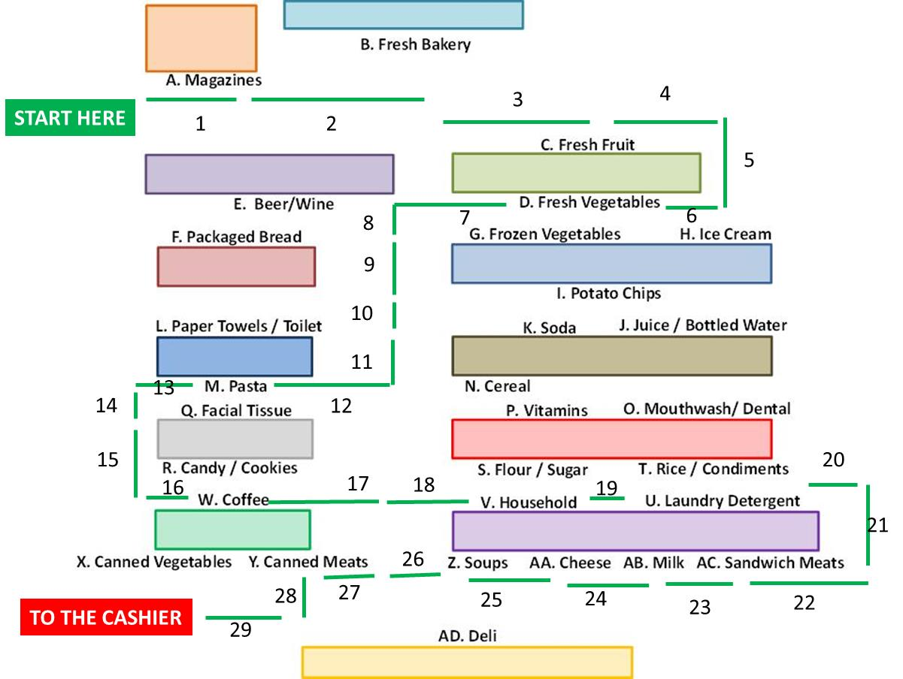

Participant went from START, to D (Fresh Vegetables) to W (Coffee) to AC (Sandwich Meats) to Y (Canned Meats) to CASHIER. This encompassed 29 stops

Path length is the number of “stops” passed or stopped at. The stops are not equal distances apart – this is not a distance measure. “Stops” are named shelf areas/sections (A through AD), vertical aisle centers (i.e., if the participant enters the center or end aisles), and opposite sides of the shelf.

To get from START to D, the participant:

|  |  |  |
| --- | --- | --- |
| PASSED A. Magazines | 1 stop | 1 |
| PASSED B. Fresh Bakery | 1 stop | 2 |
| PASSED C. Fresh Fruit | 1 stop | 3 |
| WENT to right aisle | 1 stop | 4 |
| Went vertically from C-side to D-side | 1 stop | 5 |
| Stopped at D. Fresh Vegetables | 1 stop | 6 |

To get from D to W, the participant:

|  |  |  |
| --- | --- | --- |
| Went to center aisle | 1 stop | 7 |
| Went vertically, passing the G-aisle | 1 stop | 8 |
| Went vertically, passing the I-aisle | 1 stop | 9 |
| Went vertically, passing the K-aisle | 1 stop | 10 |
| Went veritically, passing the N-aisle | 1 stop | 11 |
| Went horizontally, PASSED M. Pasta | 1 stop | 12 |
| WENT to left aisle | 1 stop | 13 |
| Went vertically, passed the Q aisle | 1 stop | 14 |
| Went vertically, passed the R aisle | 1 stop | 15 |
| Stopped at W. Coffee | 1 stop | 16 |

To get from W to Y, the participant:

|  |  |  |
| --- | --- | --- |
| Went to center aisle | 1 stop | 17 |
| PASSED V. Household | 1 stop | 18 |
| PASSED U. Laundry Detergent | 1 stop | 19 |
| WENT to right aisle | 1 stop | 20 |
| Went vertically from U-side to AC-side | 1 stop | 21 |
| PASSED AC. Sandwich Meats | 1 stop | 22 |
| PASSED AB. Milk | 1 stop | 23 |
| PASSED AA. Cheese | 1 stop | 24 |
| PASSED Z. Soups | 1 stop | 25 |
| Went to Center Aisle | 1 stop | 26 |
| PASSED Y. Canned Meats | 1 stop | 27 |
| Went vertically from Y-side to Cashier side | 1 stop | 28 |
| Went to Cashier | 1 stop | 29 |